CS-570 INTRODUCTION TO HUMAN-COMPUTER INTERACTION  
SPRING 2014 | IRENE RAE

PROJECT 1: WEB-BASED SERVICES

NAME LASTNAME, NAME LASTNAME, NAME LASTNAME

TRAVEL EASY

**INTRODUCTION**

When we were first coming up with possible ideas for our project, we all came across the idea of travel. We have used many different websites to plan trips, but sometimes we don’t always know where to go. Often we can’t even find people to go on a trip with us. As college students, we noticed that many of our friends have busy lives, and cannot pick up and leave whenever it is convenient for us. This sparked an idea for our project: we wanted to come up with a website that could offer travel destinations, and also match you up with someone to travel with.

We started with the idea of creating a website that would just be used for travel recommendations. We were leaning towards creating a site similar to Pandora, where you would enter in somewhere you have been, and the site recommends a new destination for you. We added on the idea of traveling with friends.

There are no popular sites that we are aware of that accomplish both of these tasks. Most travel websites are targeted towards people who already know where they want to go. We want to allow the user to explore different destinations based on their interests. There is plethora of travel websites, each with a specific purpose such as a site for looking for flights and hotels, a site for travel photo galleries, a site for destination ratings, and a site for matching travel buddies. We would like to make a site that would incorporate two or three of these major elements that will serve as an easy-to-use consolidation for travelers. Ideally, this website will recommend some destinations to the user, search for good deals given a chosen.

As most people like to travel, our target user group is the general public, and more specifically, people who enjoy traveling for fun.

The most used internet resource that we knew of at the beginning of this project was google. Whenever we planned vacations, we would start with google. Simple searches like: “somewhere warm” or “where to go on vacation”. Other travel sites that came to mind were Yelp and Travelocity. Searching to find a travel matching site yielded a few different sites; travbuddy.com was an existing site, although none of us had heard of it. Looking into it, it was similar to what we had in mind, but didn’t seem very user friendly.

There are a few potential problems with creating this site. A big one that we saw was implementing a way to match people and their destinations and with other people. There are a lot of places that people could travel. Lastly, we had a lot of different functionalities in mind. The wealth of information that we needed luckily could be used from already existing sites. As for implementing all of the different functionalities, we decided we would see what was most important to the users and go from there.

**UNDERSTANDING**

Our contextual inquiries gave us a lot of insight into how a person researches travel. Among our subjects we selected for contextual inquiry, in order to get a better sense of the needs of different user groups, we interviewed one literature professor who is in her 50s and two UW-Madison students in their early 20s.

As the main goal of destination recommendation is relatively specific and we are not sure if a site with a similar purpose is in use, we decided to frame our questions in a more open-ended manner when we conducted our contextual inquiries. At the beginning of our contextual inquiries, we generally framed our tasks in the following manner: “ If you want to go on a trip, but don’t have a destination in mind, what would you do to figure out or get inspiration on where you would want to go?” or “Where would you start when you are planning a trip?”.

These interviews all took place somewhere where the users felt comfortable. Two took place in the users’ living rooms, and the third by the fireplace in Union South. All three of the interviews were with users that had no problem speaking their mind so consequently the communication flow was very smooth.

The users started the process of finding a destination without hesitation. The goals that the users had in common were to go somewhere relatively new to them, and for a good price. Two of the users started without destinations in mind. The other narrowed his destination search down very quickly, and began to look for cheap hotels and transportation.

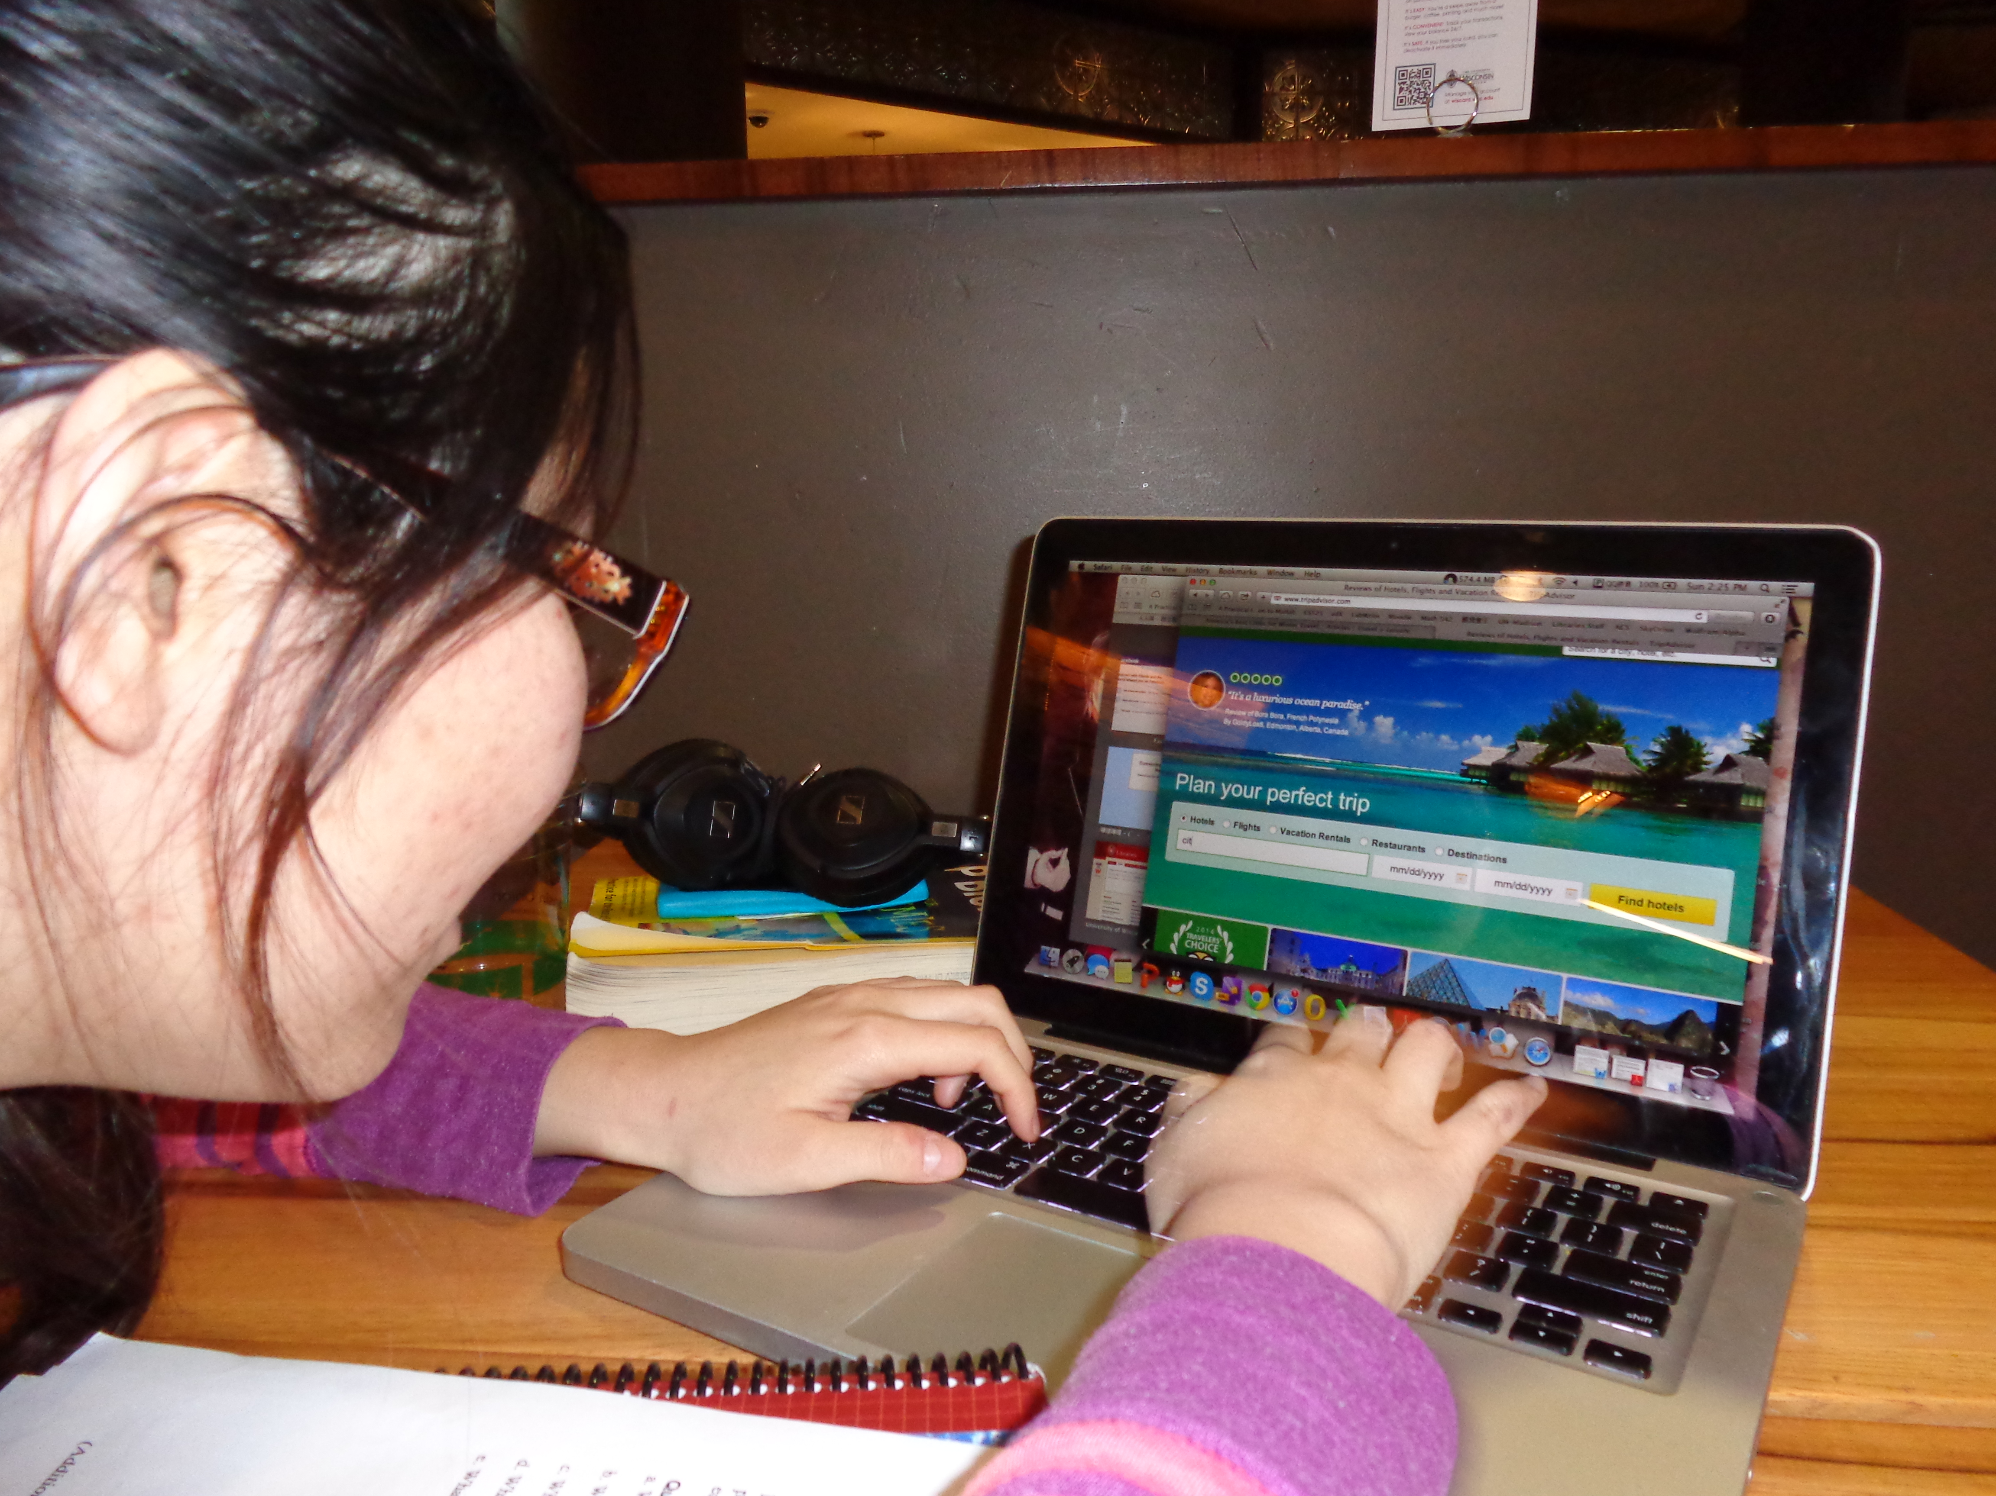The users started the search process in many different ways. Two of the users used google immediately; the other checked her email and used other airline sites to find cheap flights. One of the users started by looking at google maps. He quickly found a location and then used google to search for hotels and train fares. He then followed different links to websites he had never used before. He spent a lot of time looking at pictures to base his decisions off of. He also wanted to see event and reviews.

The other user who immediately used google searched for travel destinations and followed the results to a blog. Like the previous user, she mostly gauged the value of destinations by pictures and skipped a lot of the text. She used multiple similar travel sites. The main features she wanted to see were general weather, forecast, and transportation. She also had no luck finding a destination using any of the websites, as they all required her to have a destination in mind.

The last user looked through her email to find airport deals through her travel account. She used multiple airlines’ websites. The websites were not very intuitive for her to use, there were many different ways to get to similar pages. Her main points of interest were to find somewhere that was a getaway vacation and to find a good deal.

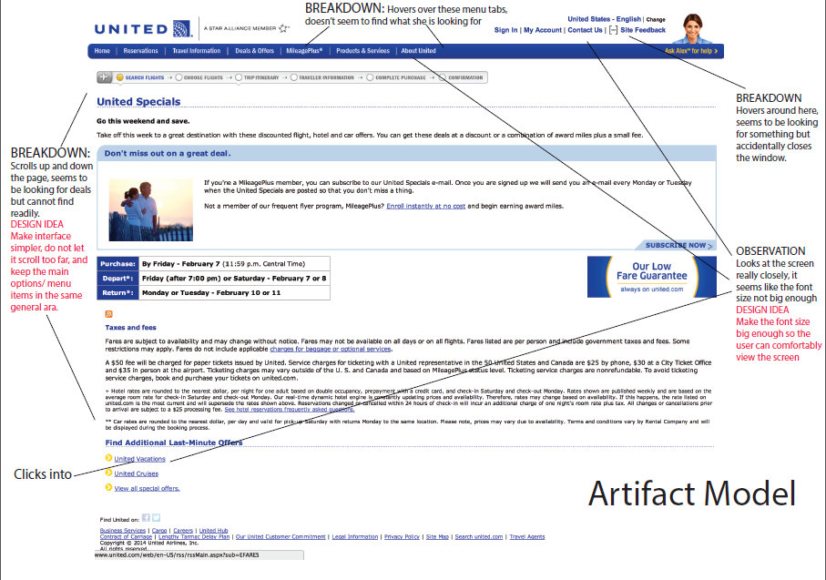 Two users were able to find destinations, but there were a few workarounds. One user often scrolled up and down the page and hovered over menu tabs until she directly typed in “deals” in the search box after she wasn’t able to find it from the menu tabs. Another user ended up going back to a website he had previously been on by following a different link. The workarounds that we saw seemed to be caused by confusing layouts.

We asked the users what functionalities they thought a great travel site would have. The results were: to include deals-related functionalities, making activities and events clear, having an interactive calendar, a lot of pictures, reviews and ratings, and ‘explore’ button, and having bullet points of information.

We created some work models that were helpful in understanding how the user uses available tools. The flow diagram helped us to understand different resources that were helpful when planning a trip. Things like hotels, transportation, money, and weather were important destination details that we wanted to be sure to include.

Another model that helped us in our design was the artifact model. The main things we gained from this was learning that tabs were helpful, and that a lot of text was less helpful. This showed different breakdowns that occurred that we wanted to avoid in our site.

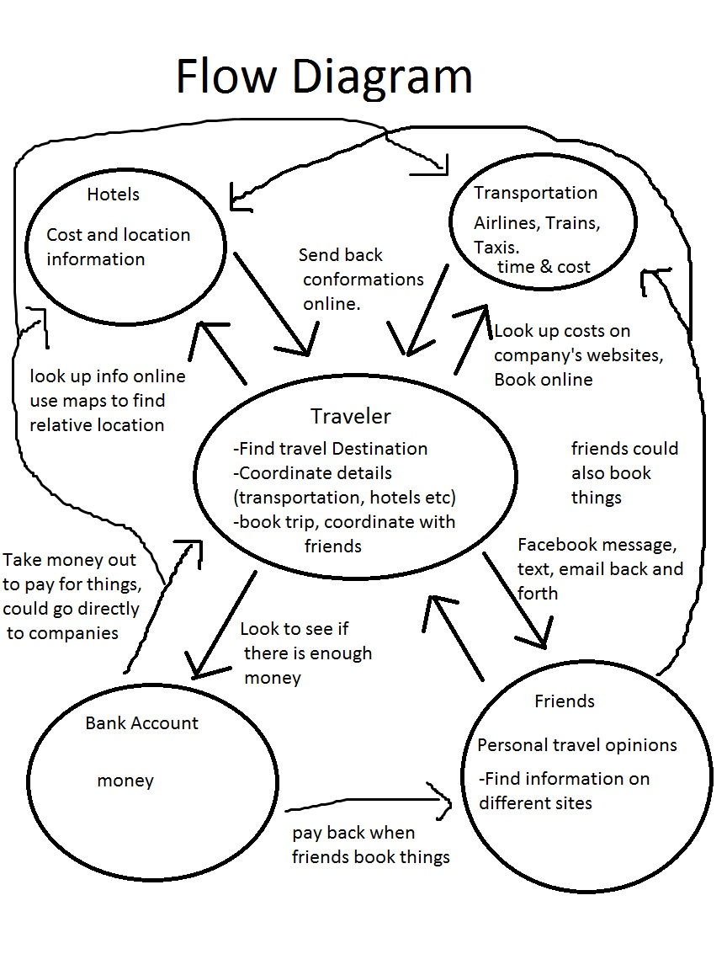

The first step towards making a prototype was to organize our ideas through an affinity diagram. We had six categories that we put observations from our interviews in: Approach, Coping Strategies, Strategies, Navigation, Priorities search, and web resources. We used this to help come up with our design ideas.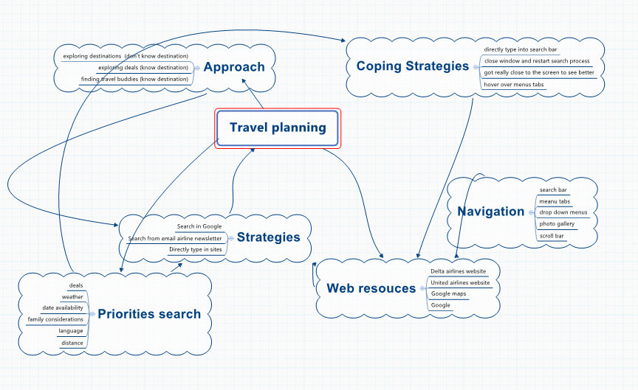

**IDEATION**

From our contextual inquiry experience, we learned various user needs by observing them and asking them questions. Some of the design insights we have gained include: (1) Allow the users to have options, instead of just being a destination recommendation site, also include functionalities such as searching for deals and matching travel buddies as extra options; (2) add a search box as a backup in case the user has difficulty navigating the site; (3) have appropriate font sizes so the users can be comfortable while using the interface; (4) create a minimalistic, accessible and intuitive interface where the major functionalities can be found in the same general area and make use of internet conventions such as the regularly recognizable icons; (5) add a photo gallery for the destinations and an event calendar, as these are elements that users typically would expect from a travel site.

Our first idea was to make a simple interface with tabs for each of our general ideals and use a lot of pictures.

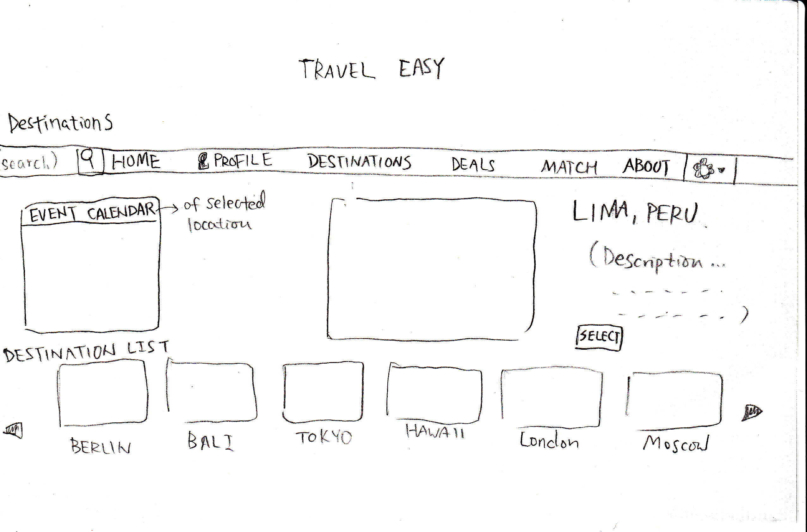

The main points that we wanted on the destinations page were to have a slider with different pictures of the destination, an interactive calendar that had events on it, a short description and a main picture. This was the first page that we designed since our main functionality is to give destination ideas to the user. We also incorporated a search bar on each page in case the user couldn’t find what they were looking for by using the tabs.

Another page that we decided to design based off user input was the deals page. This would list off different deals and give a quick description with minimally the location, the dates and the price. We also included a calendar on this page that would have deals based on the dates the user chose.

Our idea for the home page was to use pictures, a calendar, and give an explanation of how the site works. This was to keep it simple and to incorporate the ideas that our users found most important.

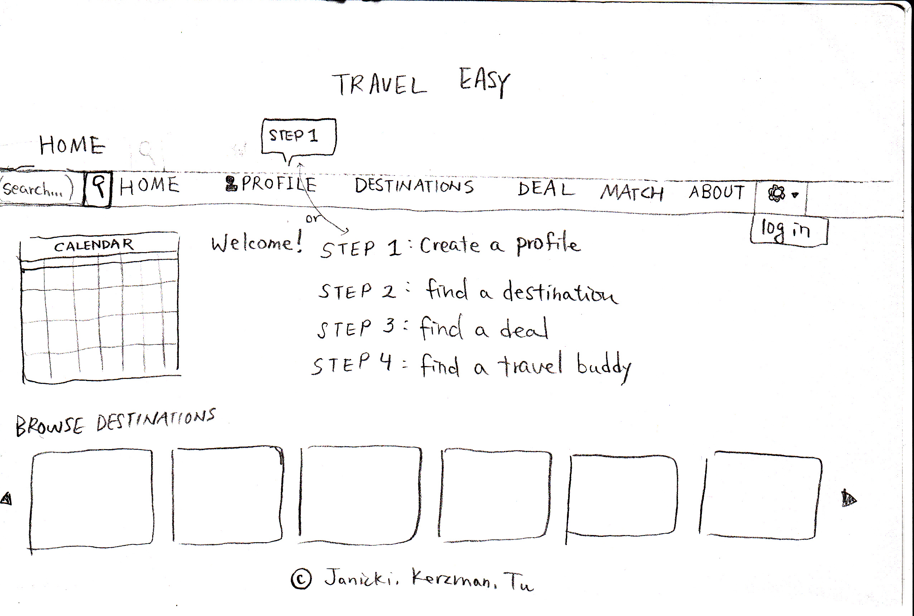

We also came up with ideas for how we wanted our match page to be. We didn’t get a lot of input on this in our CIs since our users primarily looked for destinations on sites that didn’t offer matching services. We did however follow their ideas to keep it simple. We decided to have a larger version of the profile you were looking at on one side of the page and have a slider with other possible matches on the other side. The other profiles would contain a simple bio and the interests they had in common. We decided that this would be something we would try to focus our talk aloud on since we didn’t get as much input during our interviews.

We also wanted to have a page to set up or view your personal profile. This would include a picture, your name, age, gender, interests, and available dates.

**PROTOTYPES**

We created a many different prototypes throughout this project. We started with a paper prototype that we used to develop our ideas. From there we created a simple and clean html prototype. It had tabs for a profile, destinations, deals, and matches. There was also a calendar.

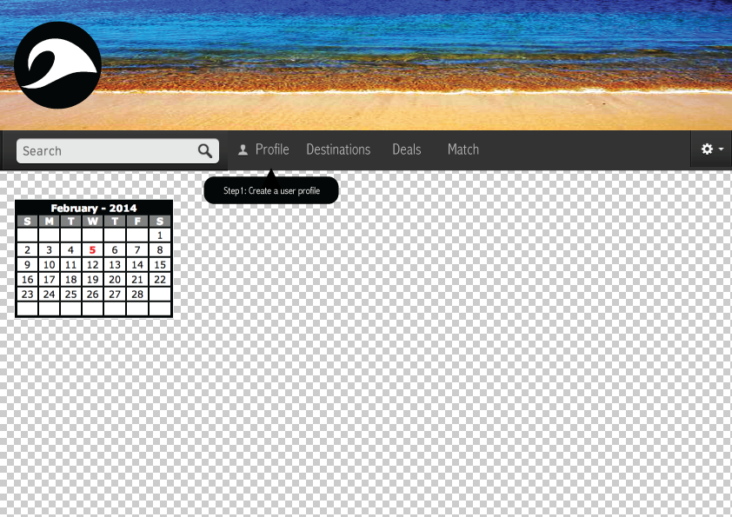

**EVALUATION**

In this section, describe the evaluation your team has conducted at various stages of your prototyping and development of your final solution. Describe the methods you have employed and your findings.

**FINAL SOLUTION**

In this section, describe your final solution. Include screenshots and the scenarios that you focused on in your implementation of the final solution. Describe what technology you used for implementation.